190905104
Parth Shukla
Lab 7

Design of VLANs Using GNS3

1)

First we need to configure the switch to the port numbers, VLAN numbers and the type of connection.

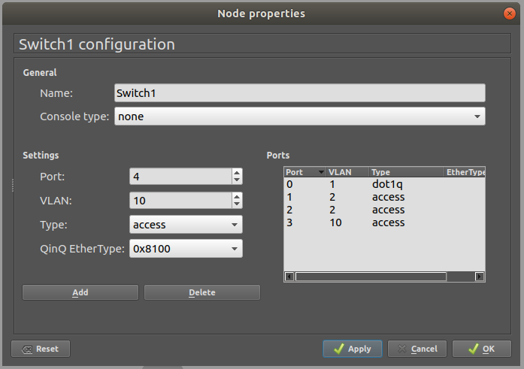
Port 0 – dot1q type connection for the router to route between VLANS. The standard defines a system of VLAN tagging for Ethernet frames and the accompanying procedures to be used by bridges and switches in handling such frames.
Port 1 – access type for VLAN 2
Port 2 – access type for VLAN 2
Port 3 – access type for VLAN 3

After configuring, we are ready to make connections between the devices.
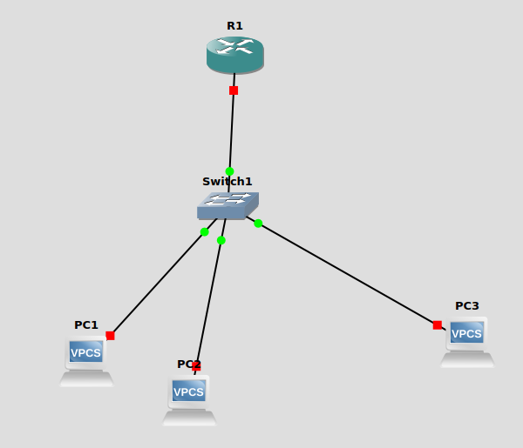
Configure Router

On the interface f0/0 we are connected to the switch. Now we must assign it the address 192.168.10.1 with the mask 255.255.255.240(total number of addresses available are 16).

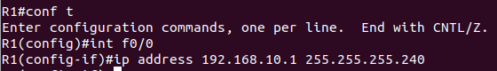
On the same router, we must configure VLAN 2 which is accessible through the switch using trunk.
We do this by switching to the sub interface on the console by the command int f0/0.2, here 2 is the VLAN number.
We assign it the ip address 192.168.1.65 with mask 255.255.255.192 i.e we have 64 addresses on this network.
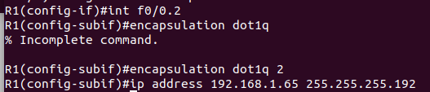

On the same router, we must configure VLAN 10 which is accessible through the switch using trunk.
We do this by switching to the sub interface on the console by the command int f0/0.10, here 10 is the VLAN number.
We assign it the ip address 192.168.1.129 since VLAN 2 has the last address 192.168.1.128 with mask 255.255.255.224 i.e we have 32 addresses on this network.
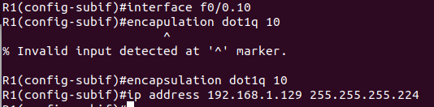
Configuring PC

Configuring PC1 with address 192.168.1.66 with default gateway 192.168.1.65
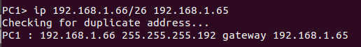

Configuring PC2 with address 192.168.1.67 with default gateway 192.168.1.65
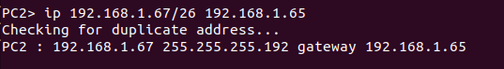
Configuring PC3 with address 192.168.1.130 with default gateway 192.168.1.129
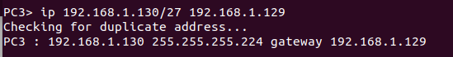
Pinging PC2 from PC1(same network)
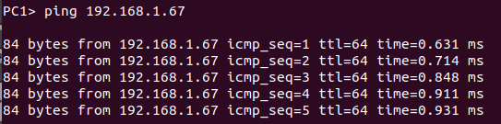

Pinging PC3 from PC1(different network)
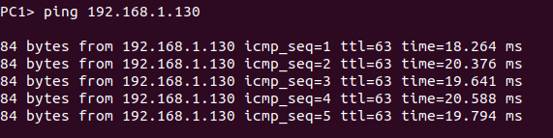
Wireshark:
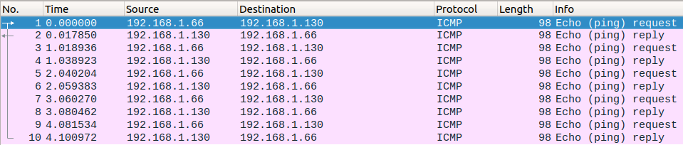
ARP showing only the default gateway address as the destination, even though on same router, is on another VLAN so after reaching the router, router routes it to the correct subnet.

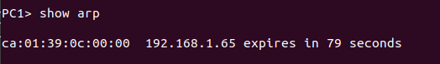

2)
First we need to configure the switch 1 and 2 to the port numbers, VLAN numbers and the type of connection. Standard practice is to assign VLAN 1 for all the trunk ports. Port 2 and 3 are connected to PC 1 and 2 in VLAN 2. Port 4 and 4 are connected to PC 3 and 4 in VLAN 3.

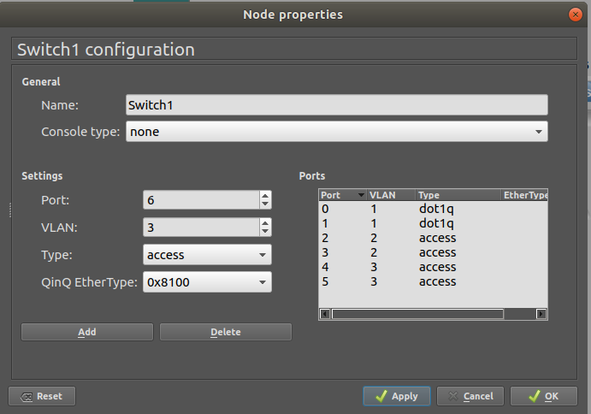

In switch 2, first port is the trunk port. VLAN assigned to it is 1. VLAN 4 in port 1 and 2 for VLAN 4.

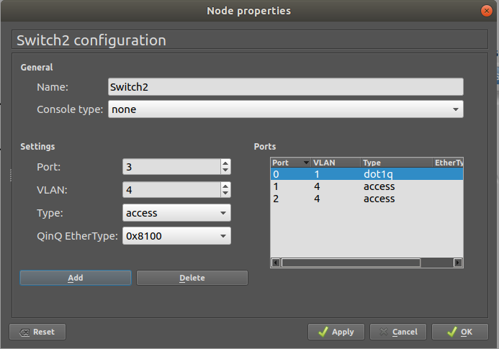

Then we can make the connections,

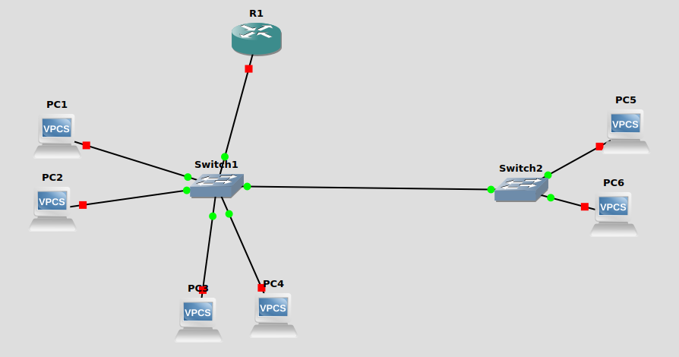
Configure Router

On the interface f0/0 we are connected to the switch. Now we must assign it the address 10.10.1.1 with the mask 255.255.255.0(total number of addresses available are 256).

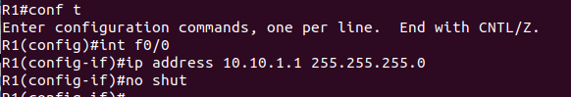
Configuring VLAN 2
We do this by switching to the sub interface on the console by the command int f0/0.2, here 2 is the VLAN number.
We assign it the ip address 10.10.1.65 with mask 255.255.255.192 i.e we have 64 addresses on this network.

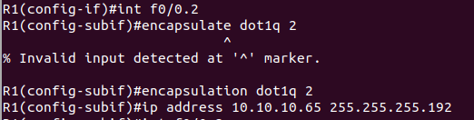
Configuring VLAN 3
We do this by switching to the sub interface on the console by the command int f0/0.3, here 3 is the VLAN number.
We assign it the ip address 10.10.1.129 with mask 255.255.255.224 i.e we have 32 addresses on this network.

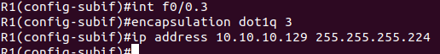
Configuring VLAN 4
Even though VLAN 4 is not directly connected to the router, it is accessible through trunk ports.
We do this by switching to the sub interface on the console by the command int f0/0.4, here 4 is the VLAN number.
We assign it the ip address 10.10.1.129 with mask 255.255.255.224 i.e we have 32 addresses on this network.

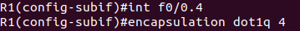

Network details:

VLAN 2
PC1 – 10.10.10.66/26 default gateway 10.10.10.65
PC2 – 10.10.10.67/26 dafault gateway 10.10.10.65

VLAN3
PC3 – 10.10.10.130/27 dafault gateway 10.10.10.129
PC4 – 10.10.10.131/27 dafault gateway 10.10.10.129

VLAN 4
PC5 – 10.10.10.197/27 dafault gateway 10.10.10.196
PC6 – 10.10.10.198/27 dafault gateway 10.10.10.196

Pinging PC6(VLAN 4) from PC1(VLAN 2):
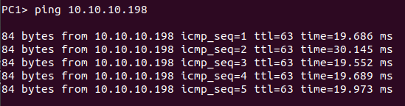
Successful capture:
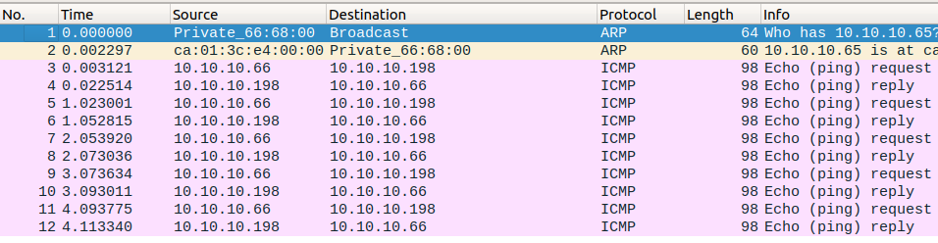
ARP showing only the default gateway address as the destination, as the address are private in VLAN, so after reaching the router, router routes it to the correct subnet.
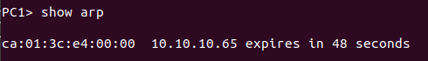

Pinging PC6(VLAN 4) from PC3(VLAN 3)

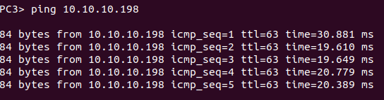

Pinging PC4(VLAN 3) from PC1(VLAN 1)
